Describing a future for the Northern Local Care Partnership and One Northern Devon

Background
One Northern Devon (OND) is a partnership of organisations that recognise that unfair and avoidable differences in social, economic and environment conditions affect the opportunities people have to lead health and happy lives. It was formed to improve the health and wellbeing of North Devon and Torridge residents by taking collaborative responsibility for ensuring the strategies and plans of local public and voluntary services are joined up and targeted to the needs of the population, offering a more seamless system of services that works better for residents.
When the Devon Clinical Commissioning Group transitioned formally into an Integrated Care System in 2022, work that had already begun around the formation of a Northern Devon Local Care Partnership (NLCP) was progressed. Local Care Partnerships were set up to be collaborations between a wide range of organisations and groups who help people live happier and healthier lives, in order to better support people and communities. The Northern Devon LCP covers areas such as Hartland, Lundy, Ilfracombe, Lynton, South Molton, Barnstaple and Holsworthy.
This has resulted in 2 distinct partnership organisations with shared goals. Whilst there have been endeavours over the past 12 months to bring OND and the LCP closer together and some progress made bringing the work into a single LCP workplan, there is opportunity to review this situation and look at a future where the LCP and OND are aligned as one to deliver the same agenda and improvement for the people of Northern Devon.

System Context:
The Devon Operating Model outlines 22/23 and beyond responsibilities for Local Care Partnerships as:
- Improving performance of local services where joint working can improve overall performance
- Planning changes to the provision of services in place to deliver improved integrated care and improved performance
- Delivering relevant strategic priorities for Devon that apply to the local population
- Procuring and securing health and care services to meet the needs of local communities, commissioning at the level of place

The Joint Forward Plan outlines the following priorities (in summary):
- Every suicide should be regarded as preventable
- PHM will be everybody's responsibility
- People in Devon will be supported to stay well at home
- People in Devon who need end of life care will receive it
- People in Devon will have the support, skills and knowledge they need to confidently involved as equal partners in all aspects of their health and care
- Children and young people will have improved mental health and wellbeing
- The most vulnerable people in Devon will have accessible, suitable, warm and dry housing
- Equality, diversity and inclusion will be everybody's responsibility
- People in Devon will be provided with greater support to stay in employment
- Local communities and groups will be empowered to become more resilient, recognising them as equal partners

We recognise that at present, the Northern LCP as it stands is not delivering on all of the priorities set out as above but there is ambition to achieve this. We believe that by bringing together One Northern Devon and the Northern Local Care Partnership, we can collectively achieve these goals in a stronger approach, drastically improving the lives of people in our communities.

Current State
At present, there is a shared understanding that One Northern Devon sits within the Northern Devon Local Care Partnership as a key partner and collaborator. Key partners from OND have been embedded into the NLCP structure, and vice versa with crossover at both OND Board, NLCP Executive and NLCP Programme Group level – not to mention the multiple partners that collaborate on delivery within both OND and the NLCP as it stands. However, OND remains a distinct organisation with its own Board, budget and priorities.

Current Northern Local Care Partnership Structure:
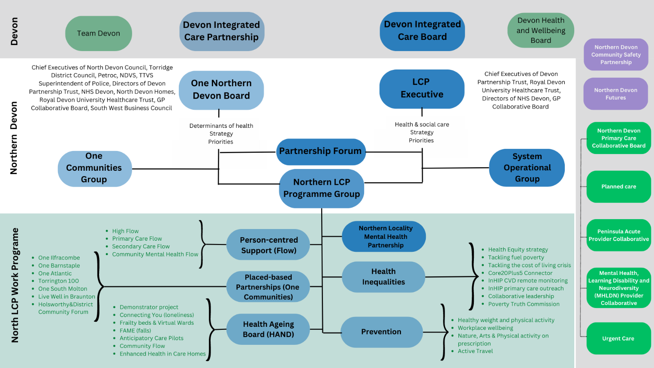
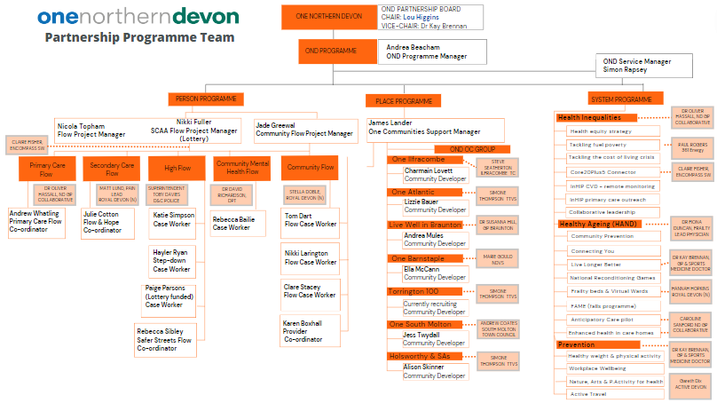
Current One Northern Devon Structure*:

Proposed future state
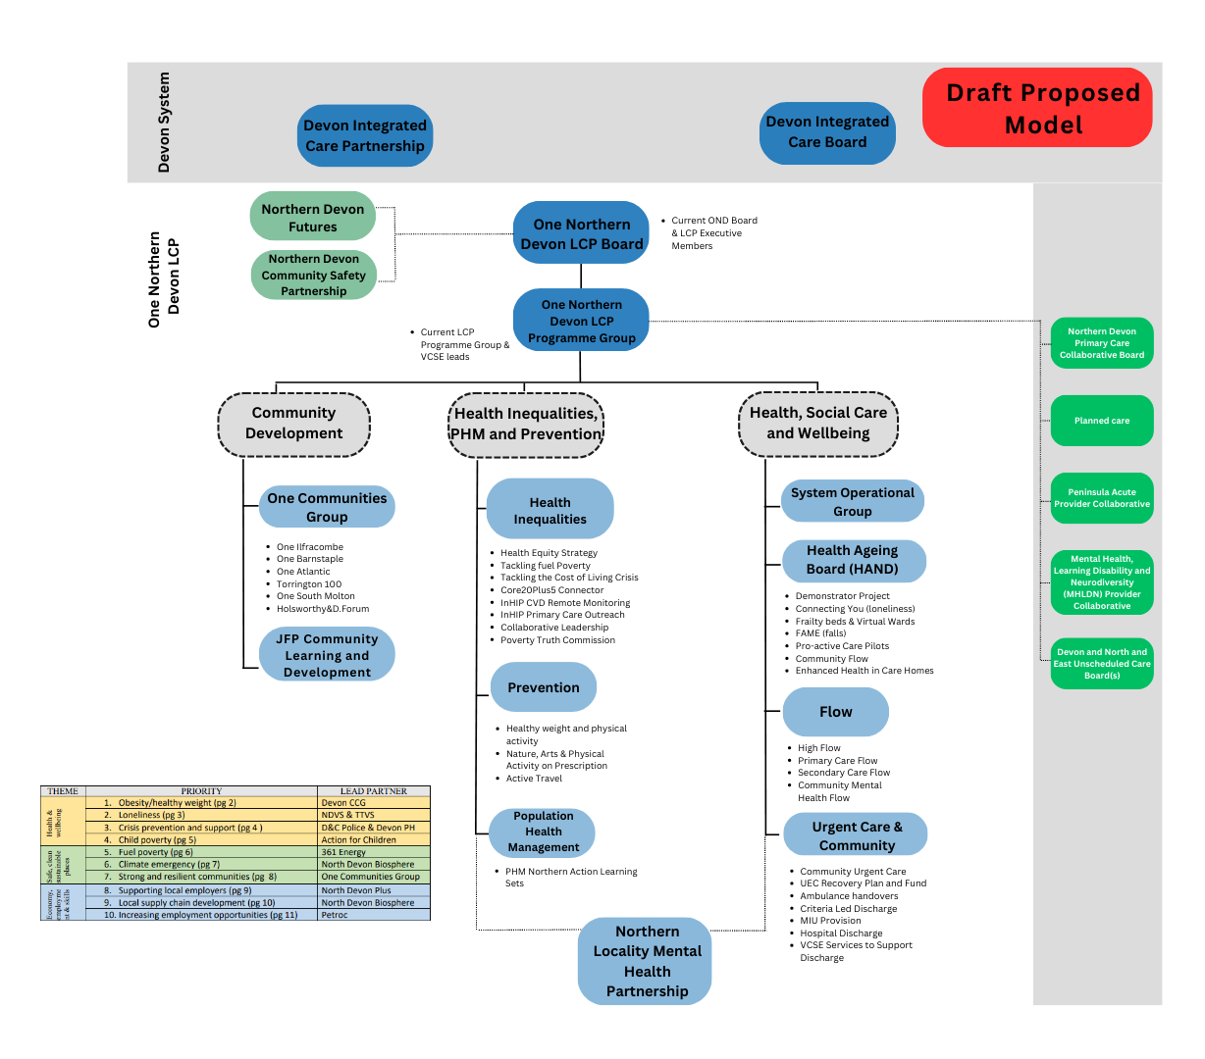
The below governance structure, sets out a draft model in which One Northern Devon evolves and merges with the current Northern Devon Local Care Partnership:

SWOT analysis
Strengths | Weaknesses
- Could make us a stronger LCP  - Initial conversations show that executive partners at both OND and LCP level agree this evolution makes sense  - Reduction in duplication and better use of resources  - Concentrated collaborative effort aligned around shared goals  - Removes financial fragility currently facing OND | - Some historical relationship challenges would need addressing
Opportunities | Threats
- May increase funding allocation opportunities  - We can re-brand our LCP based on this evolution and begin a further cultural change both at system and local level  - There is an opportunity to positively review our resource and capacity  - Alignment of workplans and focus on shared priorities  - Shared training and development  - Strengthen work around health inequalities and social determinants of health, progressing our contribution towards joint forward plan priorities | - Recognising that as a system we are still in NOF4  - Additional perspectives could make a focus on specific priorities more challenging  - One Towns currently feel overlooked  - Potential conflicts of interest to consider  - Both parties may feel threatened by the other in terms of a ‘take-over’  - Statutory must-do's may get in the way of the current freedoms OND currently enjoy

Risks and mitigations
Risk | Risk Description | Mitigations
ICB organisational change | The Integrated Care Board begins consultations from June 2023 which will impact workforce and capacity through until 2025 | This is not something we can mitigate as an LCP, however, we will endeavour to inform partners as and when decisions have been made
Wider partner buy in | There is a risk to certain partners or organisations not feeling included and/or not feeling they need to be included | Effective communication and engagement plan to be worked up in phase 1 of the proposed timeline
Conflicts of interest | There could be additional conflicts of interest that may need careful management | To be clear in our communication for partners this change would impact and to re-introduce a formal conflict of interest process managed at either board or programme level
One Communities | There is a feeling that they could feel displaced or overlooked | Early engagement and co-production of new model that fully embeds them into the newly formed LCP
Accountability of Board members for NHS delivery | Potential negative impact for members in evolving structure to take on new responsibilities around NHS performance | To be managed and mitigated on a case-by-case situation with guidance from NHS Devon, OND and HR where necessary
Delegated authority | Additional work delegated to LCPs in the near future, without clear direction and alignment this could have a negative impact or create complex situations | Development days continue to support conversations around shared purpose, priorities and workplans

Proposed timelines and conditions for success
We acknowledge that this, if agreed, will be an evolution rather than an overnight event. In order to make it a success, we need time, resource and support both from within One Northern Devon, the Northern Devon Local Care Partnership and the Integrated Care Board. We propose the initial draft timeline:

Options
- Do nothing, continue as we have been for the past 18 months but unable to do any real development because we don’t have clarity on our role in the system now there are other significant partnerships and overlapping agendas
- OND and the LCP merge (acknowledging that LCPs are not just about health and social care)
- OND and Northern Devon Futures merge
- OND narrows its focus to health inequalities and works with both groups to raise that agenda
- Integrate OND, NCLP and Northern Devon Futures

Recommendations
SWOT analysis on options above, completed by the OND board meeting on the 25th of July 2023
Option | Strengths | Weaknesses | Opportunities | Threats
1. Do nothing | Simple  No additional effort  Non-threatening  Some bits are successful | Creates superficial answer to ‘what are we doing about partnerships’ without substance  Faltering purpose  Reliant on a number of people, especially chairs  Deficit of democratic accountability  Risk of duplication | Flexibility  Autonomy  Freedom from additional scrutiny | Increased scrutiny of value  Legitimacy comes from community and delivery  We could be discussing this again in 2-3 years  Budget
2. OND & LCP merge | All partners will be able to influence the LCP/health system priorities  More streamlined alignment of staff, funding and strategies  Brings wider determinants of health partners into core health and social care business and infrastructure  Appears achievable  Could be expedited  Integrated mandate is bedding-in and worthy  High trust  Closer to lived experience  Authentic relationships  Already on a journey | Don’t know when, how much or what conditions will be around funding  Will still need to navigate the roles and relationships with NDF and other partnerships  Not a single voice for North Devon | Devolved funding could make OND/prevention programmes sustainable  By focussing on prevention we will delivery what is needed to save health and social care system  Improve health outcomes and reduce inequalities  Could take a more proactive approach | Could lose some autonomy where funded through the ICB  Could narrow our vision and reduce delivery  Some on the LCP may feel the agenda is too broad or not in their remit and vice-versa  OND becomes subsumed in health and social care delivery that is primarily reactive  Could be too ambitious
3. OND & NDF merge | Increased capacity for action and ding as there is less overlap and duplication  More clarity to public and partners  Keeps governance simple | Health and social care is so broad that it needs it own space, governance and strategy  Health = £££ = social care so there is a potential to miss out  NDF still ‘storming and forming’  VCSE = LCP model | Look beyond structural boundaries to truly focus on place  Simple transition, tweak the workplan and vision  NDF workstreams developed – OND – health  Engage elected members more effectively | If LCP not embedded it will grow outside this place based approach and health will dominate or distance itself  LCPs are politically influenced/vulnerable  Will OND partnerships/trust of community groups be challenged?
4. OND narrow focus on HI | Clarity of purpose  Better informed strategic group  Prevention/thriving | Two reporting hierarchies  Health | Continue with the community developers  LCP brings considerable funding | Health has lesser influence on determinants
5. OND, LCP and NDF merge | Whole system speak as one for the place  In/out of Northern Devon  Clarity with the ‘body’ who delivers and who is responsible  Greater flexibility to mobilise resources within the system  Ability to share and channel resources more effectively  Delivery better outcomes | No buy-in  Organisations protecting themselves when something changes e.g., policies  Depends on right leadership  Becomes too big  Too many objectives  Being ideological/everything becomes a priority | Eliminate duplicated resources, energy and discussions  Reduce the ‘chat’ and more to delivery  Reduce meetings  Rebrand and re-focus  Focussed objectives assigned to the right organisation  Avoid multiple vision/mission creep e.g., funding opportunities  Avoid competing against one another  Executive board for decision making  Empower all to be able to devolve power to the ‘body’ | Lack of common purpose  Lack of recognition/compliance  Democratic deficit – possible dependency of existing organisational governance  Balance – speed – number of voices  Governance structure is key  Bureaucracy – vested interests, sub-groups not letting go and fighting for inertia  Lack of ownership from those not involved in the executive board  Is it even possible?

