Devon Integrated Care System (ICSD)

Community First Strategy

Foreword

Bringing together voluntary sector, care, and health services for the first time as an integrated care system – which will be known as One Devon – this strategy outlines how effective community service delivery goes beyond helping people to avoid admission to or discharge from hospital. It is about empowering our citizens to live healthy lives, to maintain independence, to manage their long-term conditions, to support them during exacerbations and to provide the care they need as and when their health deteriorates.

The idea that the best bed is your own bed still holds true. Our recent experience of just how pressured our in-hospital services are, has underlined how important it is that people should only be in hospital where it is clinically essential, and all other alternatives have been explored.

Several organisations and members of the public have helped us to develop this strategy which reflects the holistic, multi-organisational collaborative approach that we wish to see in our community services.

We believe that by building upon the strong and effective partnership work across voluntary sector, local authority, and NHS partners that we have a huge opportunity to deliver the strategy for community services outlined in this document.

Nigel Acheson
Chief Medical Officer, NHS Devon

Acknowledgements
We have collaborated with all ICS partners on the development of this strategy to ensure that our vision aligns across health, social care and the voluntary, community, social enterprise sector. We have also engaged with the public and our service users to capture views to help to shape our understanding of the populations needs moving forwards.

Below is a list of contributing organisations and groups across our Integrated Care System (ICS).

Devon County Council (DCC)
Torbay Council
Plymouth City Council (PCC)
NHS Devon Clinical Commissioning Group (CCG)
Royal Devon University Healthcare NHS Foundation Trust (RDU)
Torbay and South Devon NHS Foundation Trust (TSDFT)
Livewell Southwest (LWSW)
Devon Partnership Trust (DPT)
University Hospitals Plymouth (UHP)
Devon VCSE Reference Group
The Mental Health and Learning Disability and Autism Provider Collaborative
The North, East, South, Plymouth and West Devon Local Care Partnership (LCP) forums
The Devon Virtual Voices Panel

Contents

Introduction

The purpose of this document is to share our vision and direction of travel for community services over the next five years (2022 to 2027). It is our aim to define how community services will look different in the future in comparison to the current landscape across Devon today. On 1st July 2022 NHS Devon became an Integrated Care System which is a partnership of health and social care organisations who come together to improve the health, wellbeing, and care of people who live and work in Devon.

Community services play an important role in keeping people well and managing acute, physical, and mental health and long-term illness. The key focus of this strategy is on preventative, proactive and personalised care to support people to live as independently as possible with greater connection to their local community ensuring people spend more time at home, wherever their home may be, rather than in a hospital bed.

We want community services, including the voluntary sector, to be far more prominent in our system with well thought out planning regarding the steps we need to take to achieve the vision, co-production of services with our system stakeholders and the public, and in ensuring that they are adequately funded to sustain delivery and outcomes in the longer term.

Devon has a strong history of integrated working, which has been built on over the last few years with several community services now being provided by, or in partnership with, local acute trusts bringing many benefits to patients, services, and the system. This has improved collaboration between services, the opportunity for the standardisation of pathways which cuts across different sectors, and potential to use the workforce in a different way, providing better continuity of care for the patient. Future developments are likely to include extension of traditionally acute based specialists out into the community, bringing more of the medical expertise to support patients in their own homes and out of a hospital setting.

Integration is widely accepted and promoted as the methodology to move health and care services forwards, including within the most recent NHS white paper ‘Health and Social Care Integration’ (February 2022). We are now in a unique position to be able to understand and evaluate the different models of integration and to share learning about what works well in being able to meet the needs of the local population by focussing on care outside of the hospital setting. As the ICS evolves further it will be important for us to be able to demonstrate the financial benefits of integrated working and how this model supports the flow of activity away from the hospital and crisis-management services, and supports funding out into the community, to create a more robust and resilient offer.

What is in this strategy
The term ‘community services’ means different things to different people. This strategy describes a vision and ambition for adult (16+ years) community services across the next five years, and it intentionally does not cover everything.

This strategy sits firmly alongside other Integrated Care System (ICS) strategies which are either published, in development or planned in 2022 and alongside our Devon response to the Long-Term Plan and ‘The way we do things in Devon’, which describes how we must work differently together as an ICS to bring about real and sustainable transformation in our health and care system.

As such, there are specific programmes, services, and population groups that you will see only referenced briefly in this strategy in the interest of avoiding duplication. These include:
- Children and Young People
- People with a Learning Disability and/or Autism
- Housing and Education
- Maternity services
- Core Primary Care services
- Hospital-based services
- Some Public-Health commissioned services
- The Community Mental Health Framework
- The ICS Digital Programme

Whilst we do not include reference to specific programmes of work or some specialist service areas as detailed above, we understand that to truly achieve improved population health we must understand that people are complex and ever-changing, as are their needs. We ask you to read this strategy with that in mind. The cultural change and ambitions set out in this strategy apply to people with physical and mental health needs, or both. They also apply to people who live with a Learning Disability and/or have Autism and to adults of all ages, ethnicities, and geographical locations. References to the term ‘home’ throughout the strategy, refer not only to those living in private residences, but to those living in other settings such as nursing and care homes. ‘Home’ as a term refers to a persons usual place of residence.

We also acknowledge that much of the positive social action happening in communities is done by communities themselves with no funding. This was particularly relevant during Covid and it is important that this strategy is aware of the impact that mutual aid and informal groups make to the health and happiness of their friends and neighbours.

This is strategy which aims to improve the delivery of community services, not only for those who need it most, but for all.

Why change is needed now

The national case for change
Improving care outside hospitals is one the of the headline commitments in the NHS Long-Term Plan (2019) which coincides with the forward view and the general practice view. The plan commits to developing ‘fully integrated community-based health care’. Including developing multidisciplinary teams, including GPs, pharmacists, district nurses, and allied health professionals working across primary care and hospital sites. International evidence proves that a collaboration takes time through strong relations, a shared vision and effective leadership. There is growing recognition of the importance between communities and health and working in partnership at a local level is key not only for meeting ambitions but addressing wider issues and inequalities.

The Kings Fund (2018) acknowledges that investing in strengthening and improving the resilience of communities can lead to better health and wellbeing alongside reducing inequalities. They state, “a radical transformation of community services is needed, making use of all the assets in each local community wherever these are to be found, breaking down the silos between services and reducing fragmentation in service delivery”. They put forward ten design principles to inform what community services look like, which include: integrating community services with other parts of the health and care system to avoid gaps and duplication between services, including through share care records and improving interoperability; making best use of community assets to plan and deliver care; empowering people to take control of their own care through more access to information; and involving families, carers and communities when planning care.

Our position in Devon
Devon has had good health and social care services for many years however, there has been steadily increasing demand on all community services both prior to and during the COVID-19 pandemic. The overall demand on all our services is projected to continue, averaging 2.9% across the next ten years, but with the added impact of COVID-19 we are likely to experience the impact of the pandemic for a long time. This will further add to overall demand on community services, projected at 3.4% annually across the lifetime of this strategy.

We have needed to operate in different ways during the pandemic, for example more remote working with system partners and an increase in remote support to people who use services. Organisations have worked together across organisational boundaries to deliver mutual aid and support or share learning and best practice in a way that wasn’t done before.

Some of these new ways of working have been successful and have brought partners working across the ICS closer together. A good example of this was how our NHS Trusts, the voluntary sector, community groups and Adult Social Care providers worked collaboratively during wave one and two of the Covid-19 pandemic including delivering mass vaccination significantly more rapidly than most parts of the UK, for which we were commended by NHSE/I. Another example is the development of the Plymouth health and wellbeing hub, where partners from across the locals system have worked alongside the public to design the best service for the local population (see below).

CASE STUDY
Health and Wellbeing Hubs

An integrated network of health and wellbeing hubs are being rolled out across Plymouth. The Health and Wellbeing Hub programme was a key commitment in the Integrated Wellbeing Commissioning Strategy developed during 2015/16 when Plymouth City Council and the CCG created an integrated commissioning function. The programme has been managed across public health, adult social care, and CCG commissioning with a range of other key partners.

Each Hub is run by a VCSE partner and was co-designed with local people. They all provide core services including a social prescribing link worker, advice and information, healthy lifestyles advice, befriending, mental health support, volunteering, a range of peer support and a wide range of other activities. The Hubs are provided in spaces where the VCSE already deliver services – there is very little additional funding involved. To date there have been around 800 individuals using the 5 Wellbeing Hubs every month. During the pandemic, the Hubs provided essential support to isolated people and families in need such as food parcels, financial advice and befriending on the telephone.

Service user example

A phone call was received from the neighbour of an 80-year-old man who was concerned he was struggling to get out the house to get food for himself. After a conversation with Adult Social Care, the hub visited the gentleman and discovered:
- The landline not working so he unable to contact anyone for support.
- The gentleman was going blind and as a result was unable to use his bank card as he had used an incorrect PIN at an ATM machine and was frozen out of his account.
- Due to his eyesight, he was unable to clean his house as he couldn’t see the dirt and grime that was accumulating.
- There was no food in the cupboard.
Arrangements were put in place by the hub to:
- Deliver six weeks of emergency food to him over Christmas.
- Ensure that Clarion Housing were aware of his circumstances and to understand why he was owing money.
- Sort out his landline via Virgin Media.
- Arrange for home care support twice a week and a deep clean of the house.
- Ensure his bank were aware of his needs and support him to access his bank account.
- Undertake home adaptations to enable him to get around more easily around his home.

Where possible we must build on these good ways of working, and ensure they are sustainable so we can continue to deliver better care in the community, especially at a time like now. Vital to this will be our ability to deliver services that keep people well, empower them to take a greater role in their own care when they are not well, deliver effective intermediate care to keep people at home or return them to their home as quickly as possible, and increasingly deliver more care in the community and away from more traditional inpatient settings.

What our data tells us

Growth in demand for our services
Our local demand modelling shows predicted annual growth across the sectors of or health and care system over the next ten years. Overall annual growth, which includes population and disease prevalence growth plus other non-demographic demand (for instance demand growth linked to new developments and patient expectation), will average 2.9% over the next decade.

The growth in community services is disproportionately impacted by our ageing population, and the increase in people living with multiple comorbidities (see figures below). As such, we expect to see 3.4% annual growth in demand for community services over the lifetime of this strategy. This is the growth we will need to offset through the actions and transformation described within this strategy to continue delivery of safe and effective community services for the people of Devon.

Figure 1: Predicted demand growth by service area 2022 to 2023.
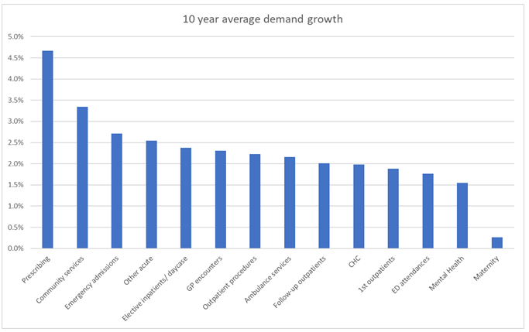

Population growth
Local data intelligence highlights that the demand for community services is continually increasing due to the high proportion of older people in Devon and the burden of chronic, long-term conditions. Overall, Devon has an ageing population with significant growth expected
from 2019 (black line) and 2040 (shaded areas).

Figure 2: Predicted population growth 2019 to 2040.
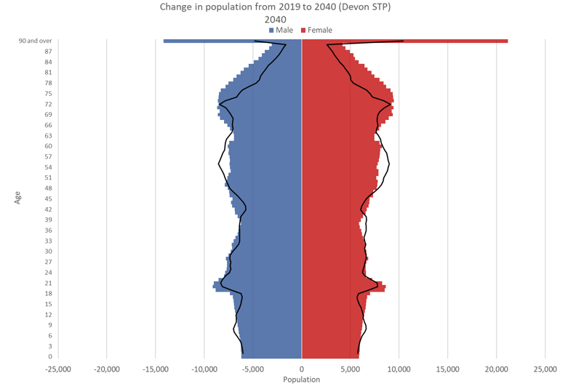
Whilst life expectancy has plateaued, the overall gap between life expectancy and healthy life expectancy has increased meaning more people will live in poorer health, increasing demand on community services and contributing to overall growth in demand. Figure 3 below shows the years of healthy life lost due to disability (YLD) per 100,000 population.

Figure 3: YLD per 100,000 population
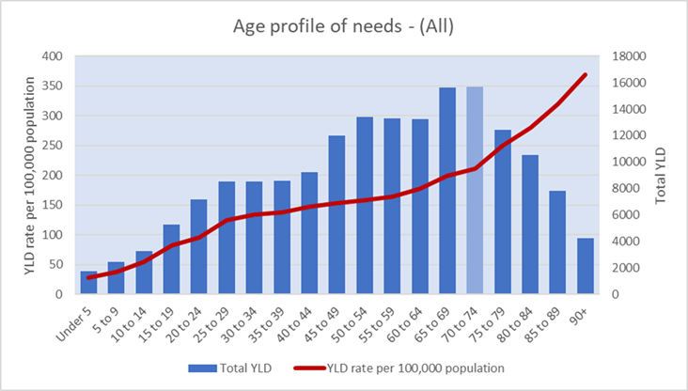

Growth by condition
Growth in demand for community services will primarily be influenced by the increasing age of the population and, as a consequence, the number of people with multiple long-term conditions.

The table below / chart below shows expected demand growth for community services by health conditions. Those condition that are primarily associated with older people have highest growth, including stoke, Alzheimer’s & dementia, cancers, MSK, falls and cardiovascular. Respiratory diseases such as COPD will see a decline in growth, although this does not include the Covid impact.

Figure 4: Community services demand growth by condition
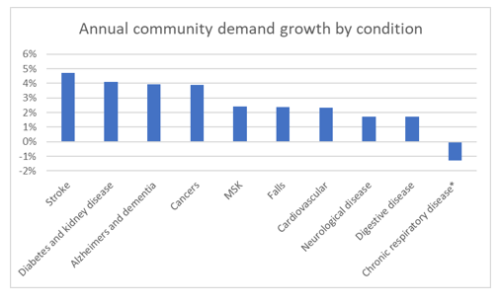

Community services and the acute bed deficit in Devon
Recent modelling has looked at our acute bed stock, to ascertain the impact of factors such as rising demand, the continue impact of Covid-19, and the seasonality effect. Using the winter of 2022 as an example, we have determined there will be a bed deficit of approximately 450 beds in our district general hospitals (DGH).
Looking at the ways to offset this deficit, it would require the equivalent of, as two examples:
- Having a 1-day length of stay reduction for all emergency admissions
- Halving the number of people in our DGHs who have no right to reside to approximately 300 at any one time
Community services have an important role to play in supporting people to stay at home wherever possible and avoiding hospital admissions, but also returning to the community as quickly as is safe to do so after an inpatient stay. Developments in virtual wards, Urgent Community Response (UCR) services, support to the discharge programme and care homes are just some of the impactful initiatives detailed within this strategy.

Deprivation and health inequalities
Deprivation is a key driver of health need across all age ranges, and we understand that the impact of the Covid-19 pandemic will be felt more on specific cohorts of the population directly and indirectly affected by Covid. In Devon:


More than 400,000 people (30% of the population), including 13,000 children, are living with one or more long-term conditions
4.5% of people live in an area counted amongst the 20% most deprived areas in the country


We expect to see a higher number of people identifying as LGBTQ+, and a higher number of people who are Black, Asian or from Minority Ethnic groups, and a growing number of people diagnosed with a neurodiverse condition living in Devon and requiring our services

The wider determinants of health
The places we live in have a profound impact on our health and wellbeing, and we know we have some enduring challenges across Devon which contribute to the context in which this strategy is developed through its impact on population health:
- Fuel poverty and poor housing conditions, particularly in the private rented sector
- Increasing homelessness and an increase in house prices due to the pandemic
- The rising cost of living
- A correlation between non-decent housing and areas of deprivation, poor health and wellbeing outcomes, and areas where acquisitive crime is higher. This suggests significant inequalities in housing quality, particularly for certain groups such as those on a low income, vulnerable families, and migrant workers, who are increasingly being reported as living in poor conditions

Workforce
This growth would be equivalent to an additional 1,600 staff. And in community services, over 3% annual growth in staff would be required to meet rising demand.
2.3% average annual demand growth will need to be met by either increased workforce numbers and/or improved productivity, including through digital developments.



Increased burnout, vacancies, turnover, and lower levels of retention. This has been compounded by the pandemic, which has impacted workload, wellbeing and inequities faced by some staff.
We have a high number of professionals due to retire from the health and care system in the next ten years, including carers who are an essential part of our wider workforce.



We know that simply looking to annually increase the number of staff working in our health and care system is not the answer, both due to the availability of potential staff and due to our financial constraints. Instead, we will need to work differently, looking at new roles, new models of working and an increased number of opportunities around rotations, flexible working and remote working.

Other key drivers for change:
- Variations in the access to, and quality of, some services according to where people live.
- Challenges in continuity of care when people’s care moves between providers.
- The need to do more to keep people at home where possible, in their usual place of residence and to avoid or delay hospital admissions by providing increasingly complex care in the community, supporting a reduction in hospital length of stay.
- The impact of the pandemic on population health and wellbeing, such as increased loneliness and social isolation possibly leading to increased mental distress or illness.
- Estate and infrastructure challenges including the need to increase digitalisation and to ensure that facilities are fit for purpose and sustainable into the future.
- The need to improve the environmental impact of our services and how we deliver them. We must achieve an 80% reduction in our 1990 baseline carbon-footprint by 2030.

For more information about the drivers for change and population health in Devon, see our ‘Whole system case for change’.

What the people of Devon say
Engagement work was undertaken in 2020 to explore what integrated care meant to people and in 2022 to gain feedback on the seven principles outlined earlier in this document. The most important things that our population want moving forwards are:
- Staff working together to deliver greater continuity of care.
- Patient centred care with services having the flexibility to tailor their offer to meet needs.
- A greater focus on prevention and earlier support rather than people reaching crisis point.
- Technology utilised to complement and not replace personal, face to face discussions where they are needed.
- More care delivered in the community away from a hospital where possible.

There are changing expectations and behaviour of people using services. This encompasses how people want to access services, how they want services to work together, their expectations and concerns when using digital services and how they want services that meet their needs to help improve their health.

How do we act upon this data?
The current infrastructure of community services in the context of the ageing population, post Covid increase in demand versus capacity, financial pressures and workforce shortages is not sustainable. There needs to be a refreshed focus on strengthening community services that encompasses prevention, health improvement and self-care.

Because of this, our Public Health commissioned lifestyle services are more crucial than ever. Along with access to good citizen’s advice, support to live in stable accommodation, access to employment opportunities and access to good community pharmacy, optometry and dental care, these services when delivered well, dramatically change the health and wellbeing of our population. Whilst this strategy does not cover these services in detail, we acknowledge that they have the most significant impact on population health, and it is our job as an emerging ICS to ensure access to these services for all our population when they need it.

We must have specific cohorts of people in mind when commissioning and delivering services such that we can minimise any health inequities between different groups, ensure reasonable adjustments are made for those who need them, and to ensure that we are engaging with and offering equitable service offers to those who are harder to reach. This should be the thread across everything we do.

Our workforce challenges across health and social care must drive the way we recruit, train, and retain staff as well as the way we are planning services for the future. This includes more delivery of care in the community that may have historically been delivered in a traditional care setting, keeping people at home or close to home as possible, and supporting our workforce to work in new ways through the appropriate use of technology.

Our vision aims and the ten domains of this strategy describe how we will transform and improve community services based on this national and local intelligence.

Our vision

Our overarching vision is to create the conditions to empower people to take a greater role in their own health and care and deliver services which use our workforce most effectively to deliver outstanding care; providing sustainable, community care based on what people tell us they need, in the place they most want to be enabled by collaborative design, commissioning and delivery across Devon ICS. If we can achieve this vision the difference, we will see is:

For people | I have input how and where my care is delivered, and have the information I need to maintain my self-care
For staff | I am spending less time on tasks that don’t add value and more time with people who need support.
For the system | We are making best use of the assets in our communities, reducing fragmentation, and improving population health.

Our aims
By 2027 we will be commissioning and delivering community services that:
- Have adequate investment and are commissioned for outcomes that are important to the people using our services utilising data to build a deeper understanding of the value being delivered rather than solely guiding the decision making.
- Encourage and enable people to be an active participant in their health and care when they are well, and equipping them with the skills, knowledge, technology, and confidence to better self-manage when they are unwell, so they can live well for as long as possible on their own terms, promoting People Led Change.
- Deliver person-centred, coordinated care that focuses on people strengths and what matters to people.
- Improve integration of workforce to enable greater collaborative working across organisational boundaries and the sharing of data across multiple systems via linked records.
- Build community capacity at neighbourhood level, informed by local needs so people have access to the services they require closer to home and at the time they need them (responsive).
- Provide proactive, reliable, resilient, safe, and sustainable community services that support people to stay in their usual place of residence or stay there for as long as possible, avoiding unnecessary hospital admissions and accelerating discharges after an acute stay.

- Reduce unwarranted variation while delivering consistent pathways of care which are resourced to deliver equity of access and outcomes with a particular focus on communities of interest across all levels of need.
- Are as accessible to people with disabilities as they are for everybody else and continually deliver a positive experience for all.

The way we will need to commission services to deliver these aims
To get the best possible services that deliver our vision these seven principles, which if embedded, will produce benefits through effective planning, innovative commissioning and collaborative involvement across the ICS resulting in improved outcomes for people, communities, staff, and the system.

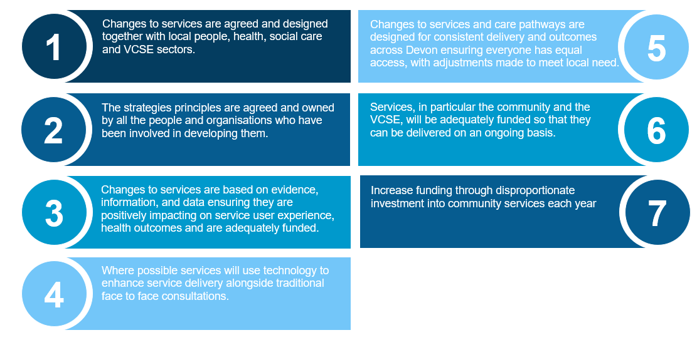

Investment into community services
To bring about the changes described in this strategy, we will need to see a shift in resources away from the acute sector and into community services, including the voluntary and social care sectors.
We have already begun this shift in the financial year 2021-22 and 2022-23, for example:
- An agreed investment of £3.2m in 2022-23 for virtual wards, rising to £4.3m recurrently thereafter
- £1.4m invested in the Shared Care Record, including for local authorities
- £750k agreed investment for the recruitment costs of overseas domiciliary care workers into the care sector
- £2.8m of investment into Urgent Community Response services in 2022-23, which will support people to remain in their usual place of residence after a crisis

Our ambition is to increase funding through disproportionate investment into community services each year, working closely with the acute and community services providers, VCSE’s and Local Authorities through our local care partnerships with a system plan that also addresses the need for financial sustainability.
We will use our population health and outcomes data to drive the areas for this investment, ensuring we do everything we can to address health inequalities and ensure our community services are funded to deliver equity in access and outcomes for our population.

The ten components of our strategy

The ten components of our strategy follow the ten areas of our Integrated Care framework which describes our approach in Devon to deliver truly integrated care in community services. The strategy itself forms the first component, being the map by which we will realise our vision and deliver integrated care across Devon ICS.
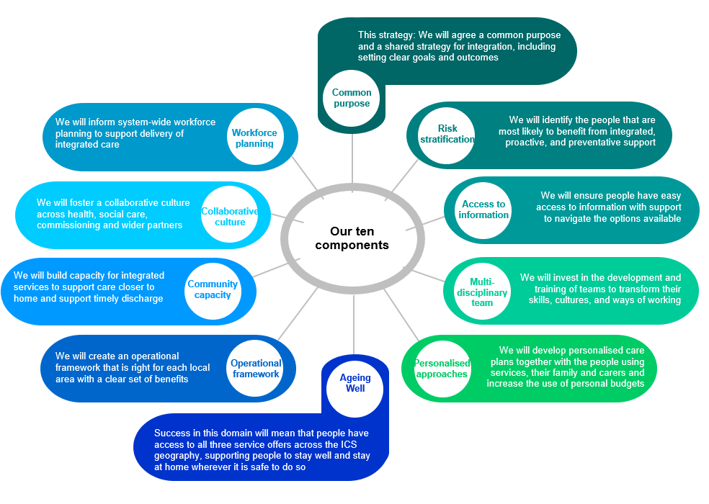

Risk stratification

Success will mean that we are able to identify the people that are most likely to benefit from integrated, proactive care.

WE WILL  - Employ Population Health Management (PHM) analytics, including risk stratification to identify the cohorts of people at neighbourhood, Local Care Partnership and system level that are most likely to benefit from integrated care as well as proactive and preventative interventions.  - Employ PHM analytics to advance strategic intelligence and commissioning and embed PHM capability into business-as-usual commissioning.  - Ensure services have the data and intelligence infrastructure to be able to monitor health inequalities in relation to access, experience, and outcomes  - Participate in the national pilot of the CORE20PLUS5 Connectors model and continue the investment in LCPs to undertake this work  - Provide anticipatory care interventions, targeted at people living with frailty, multi-morbidity and/or complex needs. These will be focussed on what is important to the individual and delivered through co-ordinated, cross sector care.  - Implement the Community Mental Health Framework (CHMF) that integrates risk stratification with the community mental health offer so that integrated teams respond holistically to people with complex needs.  - Have weekly Multi-Disciplinary Team (MDT) meetings, which focus on the most high-risk patients in each practice and offer support tailored to their needs. | THE DIFFERENCE WE WILL SEE  For people  - Care prioritised for those who need it most.  - Improved access and experience of community mental health services.  - A reduction in health inequities in line with the national ambition to increase Healthy Life Expectancy by 5 years by 2035  For staff  - PHM data being regularly used to fuel discussion, set priorities, and target specific groups.  - Improved ability to respond to those most in need.  - An increased understanding of where inequities lie and the ability to take meaningful action to resolve them.  For the system  - A reduction in health inequalities across Devon.  - A reduction in primary care, Accident and Emergency (A&E) and community team visits.

Access to information

Success will mean that individuals and their carers have easy and ready access to information about local services and community assets; and that they are supported to navigate these options and to make informed decisions about their care.

WE WILL  - Implement the Peninsula Shared Care Record (Orion Amadeus) in Summer 2022.  - Commission the use of technology and apps so that people have improved access to information about their condition and can better self-manage.  - Work with the Voluntary Community Social Enterprise (VCSE) and Social Prescribers to establish existing provision and gaps in local services and community assets and make this information available in a way that is accessible to the public and to professionals.  - Ensure the Directory of Services (DoS) is updated each time a new service is commissioned or enhanced to assure access to the right information for clinicians referring into community services.  - Ensure that shared decision making is employed such that we can inform and empower people to take a greater role in their own care and move towards a value-based approach rather than an activity- based approach.  - Provide care navigation support through services such as social prescribing and health and wellbeing hubs.  - Use effective comms to let our population know about the changing ways of delivering healthcare, for example more acute care being delivered outside of the traditional hospital setting. | THE DIFFERENCE WE WILL SEE  For people  - Increased use of technology at home for more than 10,000 people per year from 2024 through virtual wards  - Increased confidence in ability to self-manage.  - Improved access and connection with community wellbeing offers.  For staff  - Improved visibility of health and care information via the Shared Care Record for all those delivering direct patient care and whose organisations meet the required standards by 2023.  - Up to date information on all community services via the DoS.  For the system  - ‘One version of the truth’ through use of the shared care record.  - More appropriate use of NHS services.  - Increased focus on the value that a particular service can add to a person’s wellbeing.

CASE STUDY
Volunteering in Health Link Workers

A Volunteering in Health’s (ViH) Link Worker Service offers support to people at home to help them to find the information, services, and activities they need. Since starting in October, the Link Worker has taken on 33% of all new referrals to ViH which is an average of 41 visits per month, with 29% of these being referred or signposted to group activities. The system level impact of this service has demonstrated direct working between health care professionals and the voluntary sector through co-location of staff five days a week, there is a better understanding of caseloads with the ViH attendance at weekly MDT meetings along with a reduction in wider referrals due to a single point of co-ordination for all patients.

Service user example

One man suffering from anxiety and depression was referred to this service via their GP. With the support of the service, he was able to build up his confidence to attend a community group to connect with other men who were facing similar challenges.

Through further befriending support provided by the service, along with completion of the Help Overcoming Problems Effectively (HOPE) programme, his confidence has continued to grow, and he has now joined a team of volunteers at ViH as a telephone befriender. He now offers befriending to people experiencing loneliness which not only increases the wellbeing of the people he supports but has given him a sense of purpose and pride.

Multi-disciplinary team

Success will mean that the skills, cultures, and ways of working of multi-disciplinary teams have been transformed as an outcome of investment in the development and joint training of staff.

WE WILL  - Promote integrated working through an MDT approach which forms flexibly around the needs of the population, including the VCSE. Examples of this would be Urgent Community Response services, PCNs, Virtual Wards, Community Mental Health Framework, delivery of Intermediate Care and in Health and Wellbeing centres.  - Deliver joint training of MDTs in neighbourhoods.  - Develop community service specifications that include access to specialist advice.  - Use our technology and estates to create opportunities for easier MDT working and collaboration for example the development of further H&WB centres. | THE DIFFERENCE WE WILL SEE  For people  - Improved service user experience through telling their ‘story’ fewer times, maintaining our excellent 98% positive feedback on community services via the family and friends test  - Improved access to specialist input.  - A shorter length of stay in hospital due to effective intermediate care provision  For staff  - Better access to information and specialist advice for faster decision-making.  - Increased morale from team working.  For the system  - More resilient teams who are equipped with the skills to deliver a higher level of care for people in the community e.g., through virtual ward services.

[PCN case study tbc]

Personalised approaches

Success will mean that personalised care plans will be collaboratively developed together with the people using the services, their family and carers and an increase the use of personal budgets.

WE WILL  - Embed the Comprehensive Model for Personalised Care and the Universal Principles for Advanced Care Planning within community services and pathways.  - Support training and expansion of personalised care and support planning and shared decision making across services.  - Increase the use of Personal Health Budgets & Integrated Personal Budgets scaling up current offers and identifying new areas and individuals who can benefit from their use, targeting high risk individuals (including section 117 aftercare).  - Ensure that we adopt a strengths-based approach when working with people, focusing on the values, skills, knowledge and potential in both the person and their local community. In this way people will become co-producers of their support. | THE DIFFERENCE WE WILL SEE  For people  - Increased choice and control.  - Empowered participation in care planning and delivery.  - Improved individual outcomes.  - One care plan for people living with multiple conditions.  For staff  - Improved job satisfaction.  For the system  - Building skills, knowledge and confidence in self-management will lead to reductions in emergency admissions and A&E attendances.

CASE STUDY
Integrated Personal Commissioning

Integrated Personal Commissioning (IPC) is a voluntary approach to joining up health and social care for adults with complex needs along with health, social care, and education for children. It consolidates a shift in power to people who use these services to help them shape care that is effective and meaningful to them in their lives. The system level impact of this approach has resulted in closer working between the NHS and Local Authority (LA). It has built better outcomes through improved closer working between professionals and individuals along with combined clinical expertise with individuals and families/carers expertise to create person centred plans.

Service user example

A 56-year-old with complex needs had spent 40 years in a local based hospital units and in institutions since he was 10. It was difficult for his family to visit him and there was no support for him to be cared for at home. Through a combined NHS and LA support package he is now able to be at home with his sister managing his personal affairs via a Personal Health Budget. He now has his own Motability car so that he can get out and about and a local team of professionals who support him with his care needs. He is now a much happier and healthier individual with a less stressful life.

Ageing well

An Ageing Well programme has been established which has three workstreams; Anticipatory Care, Enhanced Health in Care Homes (EHCH) and Urgent Community Response (UCR). These workstreams form part of our core Intermediate Care offer (see diagram below).

Success in this domain will mean that people have access to all three offers across the ICS geography, supporting people to stay well and stay at home wherever it is safe to do so.

WE WILL  - Building on the expansion of 2-hour UCR crisis services running from 8am-8pm, we will enhance our delivery of the 2-day reablement standard, with space for local flexibility depending on population need.  - Focus on ensuring increased referrals to UCR services, particularly through 111 and 999 in 2022 and 2023.  - Develop our Anticipatory Care model for Devon by Q3 of 2022/23.  - Improve support from the NHS to Care Homes by delivering the clinical aspects of the Enhanced Health in Care Homes framework. | THE DIFFERENCE WE WILL SEE  For people  - 80% of people seen by the UCR crisis team within 2 hours by 2023.  - More people supported to stay in their own home, with less hospital admissions and faster discharge home after a hospital stay.  - Enhanced health and wellbeing of people in care homes with improved access to the right care in the place of their choosing  For staff  - Increased referrals to UCR and reablement services meaning staff can support people to stay at home.  - All Care Homes having weekly GP contact to ensure regular access to the MDT and enable early identification of potential deterioration in residents to avoid unnecessary emergency GP input or conveyance to hospital.  - Staff working in Care Homes feel part of an integrated teams spanning primary, community, mental health, social care and the voluntary sector  For the system  - Reduced emergency admissions.  - Improved flow in our acute sites.

Intermediate Care
Intermediate Care (IC) is a multi-disciplinary service that helps people to be as independent as possible. It provides support and rehabilitation to those at risk of a hospital admission or who have been in hospital. It aims to ensure timely transfer of people from hospital to the community and to prevent unnecessary residential care or hospital admissions.
It encompasses the services as described below:

CASE STUDY
Urgent Community Response

Urgent Community Response is a community-based service to support people in times of crisis in their usual place of residence. The purpose of the service is to provide people who have an urgent care need with support within two hours to avoid an admission to hospital. The service is provided Devon wide from 8am to 8pm 365 days per year for people aged 18 and over.

Service user example

A patient who lives alone hurt their back and burnt their arm whilst packing to move house. Paramedics were called the previous evening who gave the patient analgesia. They spent the night in the chair unable to mobilise and called their GP urgently the next morning. In the first instance the GP called the two-hour emergency response service who, following discussion with the patients GP, agreed to increase the analgesia. The patient was referred to Integrated Care in Tavistock along with Rapid Response for further care support. Following a visit from Integrated Care, the patient was provided with the necessary equipment to help with mobilisation. The patient was able to stay in their own home with the support from Rapid Response with continued mobilisation reviews provided by IC.

Operational framework

Success will mean that the change delivered will result in clear benefits and consistency of outcomes for local people.

WE WILL  - Work with the five local care partnerships to develop and embed an operational framework which is focussed on achieving consistent outcomes and enables local service delivery which meets the needs of the population.  - Ensure that the operational framework in each local care partnership will recognise the importance of prevention in keeping people healthy.  - Develop an outcomes framework, aligned to the Western ICP framework and others in our system to ensure our focus is on commissioning for outcomes, moving further away from the traditional focus on activity.  - Outcome measurement will ensure that appropriate focus is given to cost effectiveness balanced with quality measures that demonstrate improved population health management.  - Work with the provider collaboratives to agree areas of focus for joined up development and delivery of care. | THE DIFFERENCE WE WILL SEE  For people  - Consistent delivery of equity in outcomes.  For staff  - A framework which allows staff to deliver services to meet the needs of their local population.  For the system  - Value for money balanced with longer term improvement in health outcomes and activity.  - Service design and specifications focused on outcome measures not activity.

Development arrangements for Local Care Partnerships

The Locality Executive Committee will function as a collaborative forum underpinned by a partnership agreement/MOU.

Decisions are made within current organisational frameworks and in alignment with the ICS Operating Model.
Delegated NHS/Council decisions can be made for specifically agreed service changes aligned to LCP priorities.
Delegated authority is scaled, and the Locality Executive Committee becomes collectively accountable for population health and wellbeing outcomes.
LCP Development Phase
Shadow Arrangements
Fully Operational
2022/23
2023-24
April 2024
Community capacity

Success will mean more appropriate use of capacity for integrated community-based health, social care, and mental health services, with a greater focus on care closer to home, supported by timely discharge and virtual wards.

WE WILL  - Develop both step-down and step-up virtual ward models so people are supported to stay at home while being remotely managed.  - Deliver effective intermediate care to ensure fewer people go to hospital, and when they do they are supported to return home quicker  - Develop a Digital strategy for the ICS which supports greater access to, and successful use of, technology by our staff and public.  - Work in partnership across the system to increase sufficiency and resilience of care provision to meet need at discharge and improve pathways delivering the Discharge to Assess model.  - Implement a Health and Wellbeing Centre in every PCN footprint which includes health and social care, mental health services, public health services and the VCSE.  - Ensure social prescribing is available at every GP surgery, linking people to the community activity that will make them healthier and happier.  - Use the Community Services Data Set (CSDS) to understand activity and outcomes across community services, driving service improvement and shared learning across the ICS.  - Develop a System Level Discharge and Admission Avoidance plan to review and set out a delivery model across all pathways.  - Review the configuration of Pathway 2 discharge options, collocating short-term bed-based care and maximising therapy opportunities. | THE DIFFERENCE WE WILL SEE  For people  - A shorter length of stay in hospital across identified pathways such as Frailty and Respiratory for more than 10,000 people annually by 2024-25.  - Improved access to holistic services.  - Increased use of technology to provide information, allow interaction with staff remotely, and to update with their own readings and symptoms as part of care pathways e.g., virtual wards and remote monitoring of long-term conditions.  - More days spent at home rather than in a hospital bed.  For staff  - Faster implementation of tech-enabled pathways.  - Rotational working across face-to-face and remote management modalities.  For the system  - Implementation of a minimum of 184 virtual ward ‘beds’ by April 2024 which would release a bed equivalency of 90 acute inpatient beds.

Our community approach to keeping people at home wherever possible
The diagram below highlights four key areas which directly seek to keep people at home (in their usual place of residence) when it is safe to do so. This strategy aims to move us to a place where we can increasingly have the resource, infrastructure, and clinical skill to support people with higher acuity needs in the community. In addition to the programmes below, there are several more specific services areas that support the avoidance of unnecessary admissions for people. A good example of this currently is the Devon ICS End of Life review, of which a focus is on giving people the increased ability to die in their preferred place and reducing avoidable admissions.

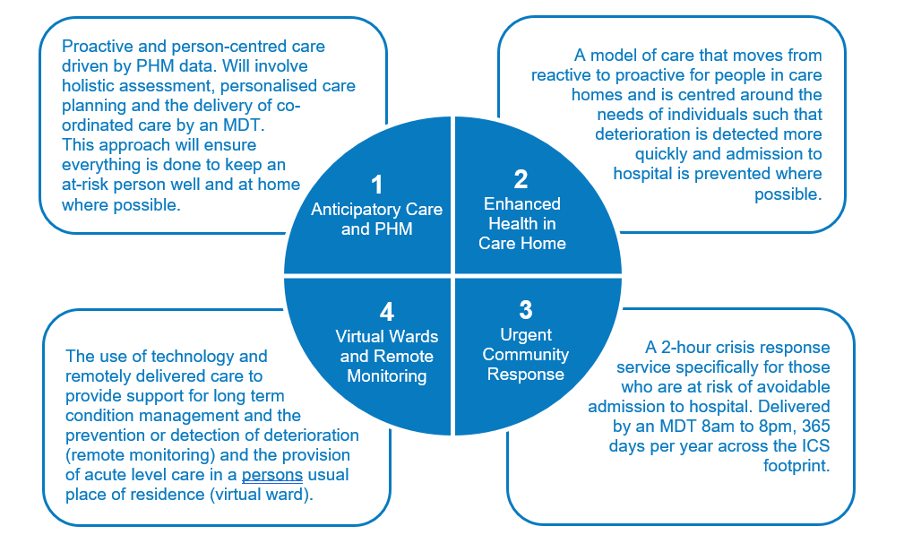

Our community approach to returning people home
The table below outlines our system approach to improving timely and safe discharges.
We know that every part of our community work must further the ambition of keeping people as home wherever possible and returning people to their homes following an inpatient stay as quickly as is safe to do so.

The table shows the different overarching elements of this work, the actions we will take to achieve them, and the related programmes and projects which will enable them to become a reality.

Element | Actions | Enablers
Understanding demand and supply | - Understanding projected need  - Market availability, supply of care home support and care home beds  - Admission avoidance  - Community reablement  - Capacity and case management | - Population health management  - UCR 2-hour and 2-day  - Anticipatory care  - Virtual wards
Improvements to discharge practice | - Transfer of Care Quality Improvement Group  - Trusted assessors  - Locality improvement plans | - Population health management  - UCR 2-hour and 2-day  - Anticipatory care  - Virtual wards
Capacity creation | - Market engagement and development  - Market rates  - Block purchase/ commissioning arrangements | - Personal health budgets  - Complex care market development  - Enhanced health in care homes  - P2/short term bed configuration
Discharge to assess | - Clear performance measures  - Consistent process application across the ICS | - Strategic DTA review

Collaborative culture

Success will mean a collaborative culture is fostered across health, social care, commissioning, and wider partners. Empowering leadership will create an environment of innovation, learning and shared purpose. We will foster trust with partners, workforce and people who use our services through openness, being curious and taking decisions to do things differently.

WE WILL  - Build and enhance our relationships with local people and partners to ensure that co-design and co-production of services is the default approach, only not being used where this is not appropriate e.g., some specialist health services.  - Use the opportunity that the formation of our ICS gives us to implement cultural change as described in ‘The way we do things differently in Devon’, including research into the potential adoption of a values-based approach to delivering health and social care  - Create an organisational development plan across the system which embeds integrated care as a consistent way of working, allowing local variation to meet need (see below)  - Make best use of opportunities for co-location of community services, for example in our Health and Wellbeing centres at place.  - Deliver our Commitment to Carers strategy and the seven guiding principles.  - Work with VCSE partners to encourage collaborative bids for funding based around forming flexible and agile teams and communities of practice.  - Have a voluntary sector alliance contract in each locality. | THE DIFFERENCE WE WILL SEE  For people  - More involvement in designing and improving services (People Led Change).  For staff  - Collaborative relationships with health, social care, and voluntary sector partners across the system  - More multi-disciplinary team working  - Increased exposure to skills development and improved satisfaction.  - A workforce who feel empowered to try new approaches to support the people they care for. To learn by doing, share success and continuously improve the way we deliver services for the people of Devon.  For the system  - Increased opportunities for  cross-organisational working.  - Increased workforce resilience and efficiencies.  - A greater focus on the value and outcomes of service delivery rather than the activity levels.

The five opportunities areas of our ICS Organisation Development programme

During the design phase of the Integrated System Development Programme an extensive diagnostic to understand the way in which the system currently works and behaves was undertaken.
The outcome of the diagnostic identified 5 opportunity areas to improve the way we work as a system. This approach has been endorsed by Senior Leaders and has been used to inform the System Development Implementation plan to:
- Mobilise energy around the change needed.
- Support a move to a positive, future focused mind-set.
- Ensure a focus on how to be different in working together and delivering care.
- Enable the conditions for a learning
- System to evolve (promoting and facilitating (learning as we do – rather than over planning).
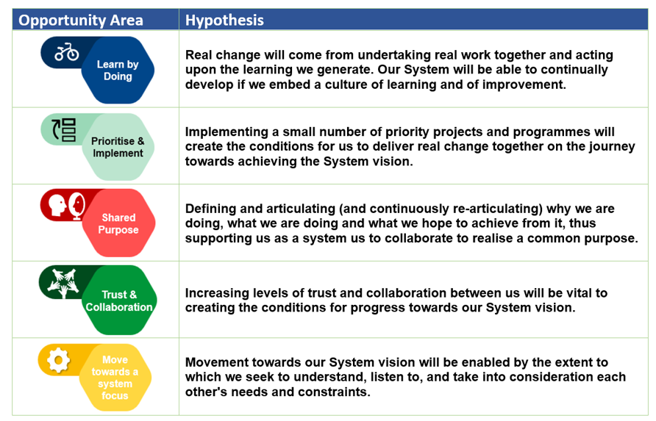

CASE STUDY
Community Mental Health Framework

The Community Mental Health Framework have enabled a change in the way that secondary care and primary care work together and in addition the voluntary sector.

This approach is neighbourhood based and tailored to meet a person’s individual needs – it reduces the need to refer people and has an open-door approach with an offer for everybody with a MH problem.

For those with SMI it offers straight forward access with a range of interventions with a streamlined approach and one model of provision between lower level and enhanced level or primary and secondary care MH.

There are also a range of interventions in place (these do vary in the 5 localities) of group work and psychological intervention.

Our current training offer for staff, based on an extensive TNA enables staff to be trained in both relevant psychological interventions and competencies.

Service user example

Workforce planning

Success will mean that workforce planning is a core process, which is aligned to the needs of the required level of change with the people strategy to help plan for the initiatives to support the longer-term vision of the community first strategy.

WE WILL  - Develop our ICS Workforce strategy in 2022 (see below).  - Scope out innovative ways of rotating staff across face-to-face and virtual modalities of delivering care where appropriate.  - Ensure that staff training and development is a key consideration in every commissioning review and service redesign piece, with a particular focus on digitally upskilling the community workforce to work in new ways.  - Ensure that staff wellbeing is a fundamental consideration during the development and review of services  - Ensure that workforce planning is taken into consideration across the whole partnership including the VCSE.  - Ensure all social prescribers hosted by PCNs and the VCSE are connected | THE DIFFERENCE WE WILL SEE  For people  - Stable workforce enables better access to services.  - Reduction in waiting times.  For staff  - Relevant training is accessible.  - Retention improved in current workforce.  - Increase in MDTs.  For the system  - IT is in place to support flexible roles and cross-organisation working.  - Established approach to rotational roles.

Our Devon ICS workforce strategy
Our workforce strategy will support us in delivering new, innovative, and sustainable workforce models across health and care. This will be achieved by identifying the right workforce needed (skills and professions) to shape and support future service delivery to meet population needs. It aims to deliver “one workforce defining the possible”.

The broader elements of strategic people management (i.e., health and wellbeing, inclusion, recruitment and retention, reward) will be delivered through supporting programs of work which form part of the other Pillars of our People Plan:
    - Workforce Strategy and Planning
    - Learning, Education & Development
    - Best Place to Work
    - Workforce Capacity

However, we recognise the importance of these pillars in achieving the ambitions set out in our workforce strategy and through strong collaborative leadership will ensure these remain connected and intertwined within the strategy evolution.

The five pillars are:

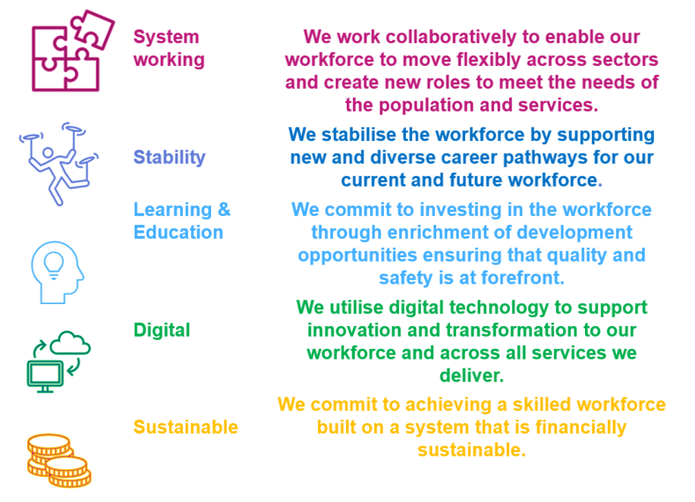

In The Next Steps for Integrating Primary Care (May 2022) it highlights the ambition for shifting workforce out of the acute and into the community setting. This will involve full alignment of clinical and operational workforce from community health providers to neighbourhood ‘footprints’, working alongside dedicated, named specialist teams from acute and mental health trusts, particularly their community mental health teams.
Measuring for success

It is crucial that we monitor and evaluate the impact of this work to assess the level of benefit it brings to local people, staff, and the wider system. We are currently developing an Integrated Care Outcomes Framework which will align with our other frameworks and will ensure a consistent set of measurements for impact analysis. They will include the means via which the metric is derived and recorded for specificity. This forms one of our key next steps.

There are several indicators that will be used to measure the success of our work, each indicator has an I statement that describes what good looks like from an individual perspective.

INCREASED CARE IN THE COMMUNITY
I have the care and support that I need to enable me to stay at home

PROVISION OF QUALITY SERVICES AND SAFE CARE
I know what to expect and that I am safe when I have treatment and care at home

ENHANCED VOLUNTARY SECTOR PROVISION
I have opportunities to join in with local community activities that are of interest to me

IMPROVED SERVICE USER EXPERIENCE
I have a voice and am listened to; what I say is acted on

REDUCED DEMAND ON EMERGENCY SERVICES
I know what I need to do if I become unwell or my health condition is getting worse

Next Steps

This strategy has defined a vision for the future of community services across Devon including several priorities to be actioned over the next five years. Whilst some progress will have been made towards delivering these priorities through services that have already been commissioned to deliver care to people in the community and/or within their own home, further planning and engagement is required to ensure that the strategy achieves its full potential.

The key next steps are as follows:

References

