

Terms of Reference
Agreed by the OND Board on 5th August 2020

PURPOSE

Who are we?
One Northern Devon is a partnership of public services, businesses, and voluntary and community groups

What do we do?
We collaborate together, influence policy & work over the long term to improve the quality of life, protect our shared natural environment and address local inequality

Why do we exist?
We exist because concerted, systematic action is needed across multiple fronts to address the causes of health & social inequalities. We need to work as ONE system to tackle complex, multifaceted factors involved

VISION
People in Northern Devon live happy and healthy lives in safe, clean and connected communities where people are supportive of one another and aspirations are achieved through equal access to the best education & employment, whilst living in decent homes and enjoying our world-class natural environment

AIMS
To create a collaborative framework that enables partnership working to improve the quality of life of residents of North Devon and Torridge and do everything we can together to create a way of life that is fairer for all.
To implement a place-based system across Northern Devon which will allow organisations to:
- work better together
- share and optimise resources
- identify practical solutions
based on the individual needs of a community.
To ensure pan-Devon and regional strategies are localised and achievable.
To reduce the current inequalities in the system.
To include all public sector services whose provision contributes to the quality of life of residents, (namely: housing, social services, employment, benefits, crime and safety, health and social care, fire and rescue, economic regeneration, parks and recreation) together with the private and voluntary sector and working in partnership with communities.
To be innovative in thinking and action, continually looking at new ways of working across the system.

APPROACH
Our strength is in being able to bring organisations and communities together to change things for the better.
Collaboration is key - there are things we can only do and problems we can only solve if we work together.
We create positive change by:

- Empowering communities
- Working together to improve services
- Challenging each other to work in a way that benefits all of us
- Acting as a collective voice for Northern Devon
- Attracting new resources to Northern Devon

GOVERNANCE STRUCTURE

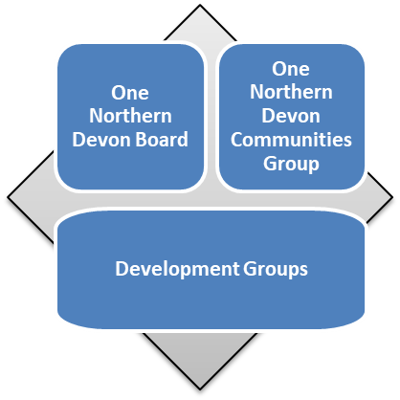

BOARD MEMBERSHIP
Membership shall be by invitation and approval by the Board. Current (August 2020) members are:
North Devon Council, Devon County Council, DCC Public Health, Torridge District Council, Devon CCG, Northern Devon Healthcare Trust, Devon Partnership Trust, North Devon Homes, Jobcentre Plus, Petroc, Devon & Somerset Fire & Rescue Service, Devon & Cornwall Police, South Western Ambulance Service, North Devon Voluntary Service and TTVS, Devon Local Nature Partnership, Primary Care Network, ND Biosphere.
The Development Groups are sub-groups of the Board. Each will determine their membership, objectives, priorities and plans in conjunction with the Board. Organisations and individuals with particular specialisms who are not Board members may be invited to join a Development Group.
The Board shall ensure the following Registers are maintained and reviewed annually:
- Register of Members’ Interests
- Risk Register

BOARD MEETINGS
Meetings shall be held every 8 weeks in North Devon. Each member is encouraged to host meetings if possible.
The Chair is able to call a virtual meeting at any time to discuss matters of immediate or urgent importance, giving at least 5 working days’ notice.
A quorum of at least 25% of the members is required to make a meeting and its decisions valid.
Decision-making is made preferably by unanimous consensus. Should a vote be required a majority of members present and entitled to vote shall show hands and a simple majority will win the vote. In the event of a tie the Chair will have the casting vote.
Members may send an alternate delegate who has equivalent voting rights.

ONE COMMUNITIES GROUP MEMBERSHIP
Membership shall comprise members of the Board plus representatives from each local One Community.

ONE COMMUNITIES GROUP MEETINGS
Meets after each Board meeting

SOCIAL PRESCRIBER NETWORK
The Network brings together all the (NHS funded) Social Prescribers with the Community Developers to build a joint approach to local provision.
APPENDICES

- OND OBJECTIVES
To develop a shared vision and objectives for Northern Devon for improving wellbeing (health, economic and environmental)
To allow opportunities for transformational change to be delivered which are difficult to achieve on an individual organisational or local basis
To develop a sustainable financing model
To work together as system leaders putting the needs of residents before the needs of organisations
To ensure the sustainability & resourcing of the ‘One Community’ model for the long-term benefit of communities and to allow the benefits to be extended to other towns across Northern Devon by:
- Supporting its communities to develop and implement local plans based on their individual needs and assets. We engage with our residents to better understand how to support them to be more independent.
- Providing joined-up services suited to the needs of the people of Northern Devon working in partnership with communities
- Bringing together the developing Ones
- To share ideas, successes, barriers
- To explore opportunities for joint working
  - Funding opportunities
  - Sharing resources

- ‘ONE COMMUNITY’ MODEL TERMS OF REFERENCE
To support communities to establish local partnerships to develop and implement plans to improve their local areas.
To provide a template for communities to use should they wish to develop their own One partnership teams using the learning from One Ilfracombe and based on the agreed principles as tested by One Ilfracombe
To ensure representation from each partner organisation in One town partnership teams as they emerge from operational members of staff who have the needed local knowledge
To unblock barriers that are reported by the individual One towns to:
To develop a single set of measures to assess the effectiveness of the way of working
To consider opportunities for working differently that individual town partnerships have identified and to support their implementation if these are:
a. aligned to the shared vision and objectives:
b. strategically aligned within their own organisations
c. evidence-based (need is established through engagement) and follow good practice
d. supports the established principles of being:
- based on an understanding of the problem through meaningful engagement with those directly affected
- person-centred
- prevention-focussed
- co-ordinated, multi-disciplinary and following an “any door is the right door” ethos
- fosters community and individual responsibility and supports volunteers
- establishes value for money
To ensure that work supported in the individual towns does not adversely impact on the service delivered in other towns
To ensure that any learning from each hub is disseminated for the benefit of the others

- OND AREAS OF FOCUS

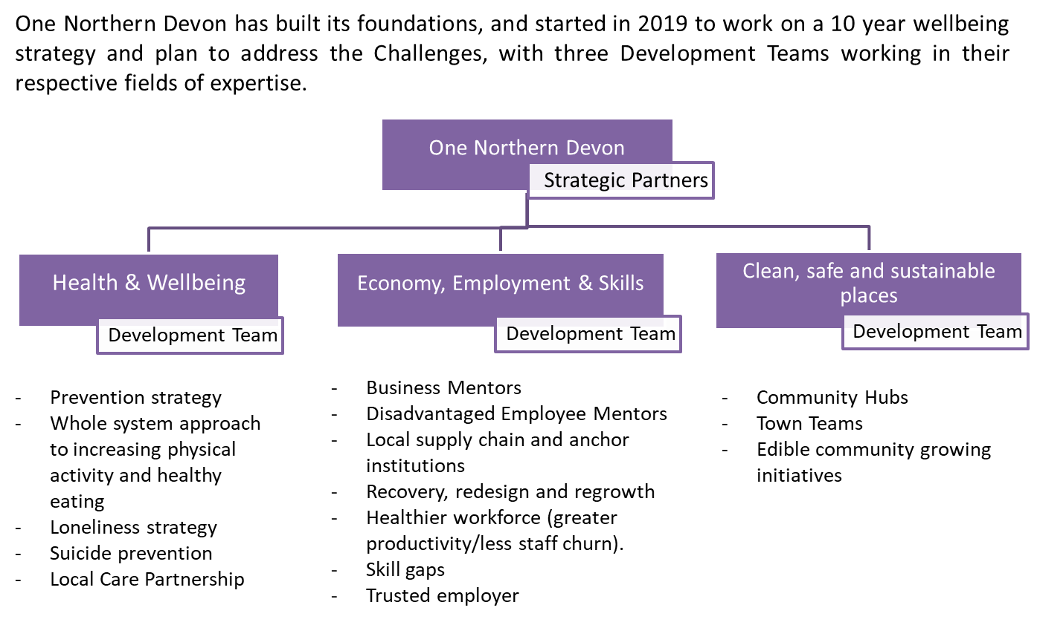

- OND’s PLACE IN THE SYSTEM

To be updated.

- CURRENT BOARD MEMBERSHIP
